UDP

UDP is a communication protocol used for time sensitive transmissions. It speeds up comms by not requiring handshaking.

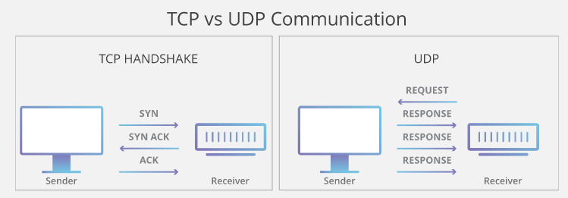

UDP in LabVIEW. Setting up the sender.

|  |
| --- |
|  |
| 1. Open a UDP connection for sending data on the desired port |
|  |
| 1. Write the data (as a string) to UDP to the desired port on the desired IP address. |
|  |
| 1. Close the connection when desired. |

UDP in LabVIEW. Setting up the Listener.

|  |
| --- |
|  |
| 1. Open a UDP connection for listening on the desired port (must match the port which is defined in the sending). |
|  |
| 1. Read the data and convert to correct type. |
|  |
| 1. Have some timeout handling logic. |
|  |
| 1. Close the connection when desired. |